**Lesson 4 Demo 10**

**Understanding Static Pods**

**Objective:** To create a Static Pod

**Tools required:** kubeadm and kubectl

**Prerequisites:** Kubernetes cluster should be installed

**Steps to be followed:**

1. Creating a Static Pod in the worker node

**Step 1: Creating a Static Pod in the worker node**

|  |
| --- |
| **Note:** Choose worker-node2.example.com node to run a Static Pod |

* 1. Create a directory at the location /home/labsuser:

**mkdir pods**

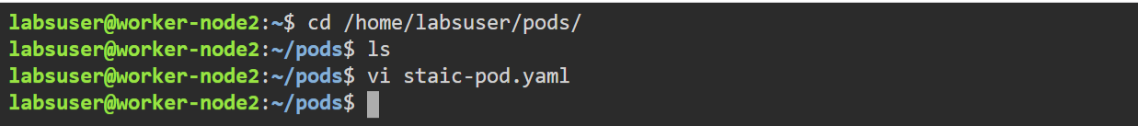

* 1. Copy and paste the static-pod path inside the following file:

**sudo vi /etc/systemd/system/kubelet.service.d/10-kubeadm.conf**

**--pod-manifest-path=/home/labsuser/pods**

|  |
| --- |
| **Note:** Mention the above line in the file on the last line, as shown in the image below. |

* 1. Write the following code in the static-pod.yaml file:

**apiVersion: v1**

**kind: Pod**

**metadata:**

**name: staticapache2**

**labels:**

**mycka: niit2**

**spec:**

**containers:**

**- name: mycontainer**

**image: docker.io/httpd**

**ports:**

**- containerPort: 80**

* 1. Run the following commands to reload daemon and create a Pod:

**sudo systemctl daemon-reload**

**sudo systemctl restart kubelet**

**sudo docker ps | grep httpd**

**sudo docker ps**

